Exp No: 1
FLASHING OF LED USING AT89C51 MICROCONTROLLER USING PROTEUS
PROGRAM
ORG 0000H
UP: SETB P2.0
ACALL DELAY
CLR P2.0
ACALL DELAY
SJMP UP
DELAY: MOV R4,#35
H1:MOV R3,#255
H2:DJNZ R3,H2
DJNZ R4,H1
RET
END
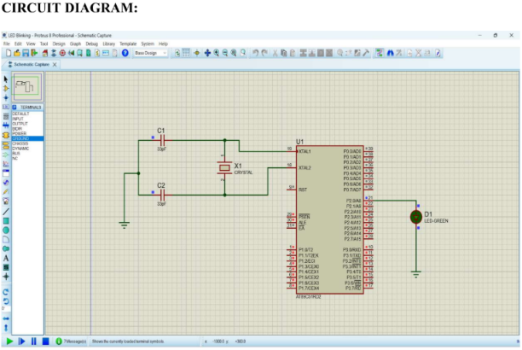

Exp No: 2
GENERATION OF SQUARE WAVE USING PROTEUS
Program:
ORG 0000H
UP:SETB P2.0
ACALL DELAY
CLR P2.0
ACALL DELAY
SJMP UP
DELAY:MOV R4,#35
H1:MOV R3,#255
H2:DJNZ R3,H2
DJNZ R4,H1
RET
END

Circuit:
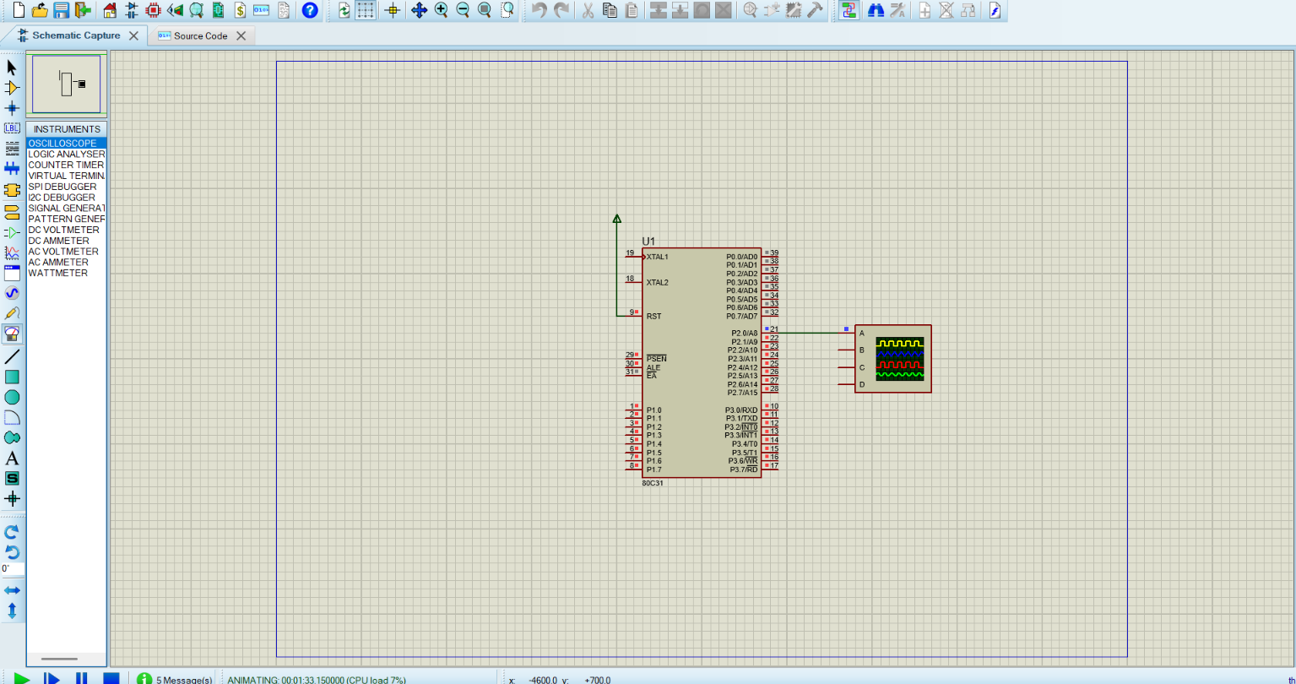

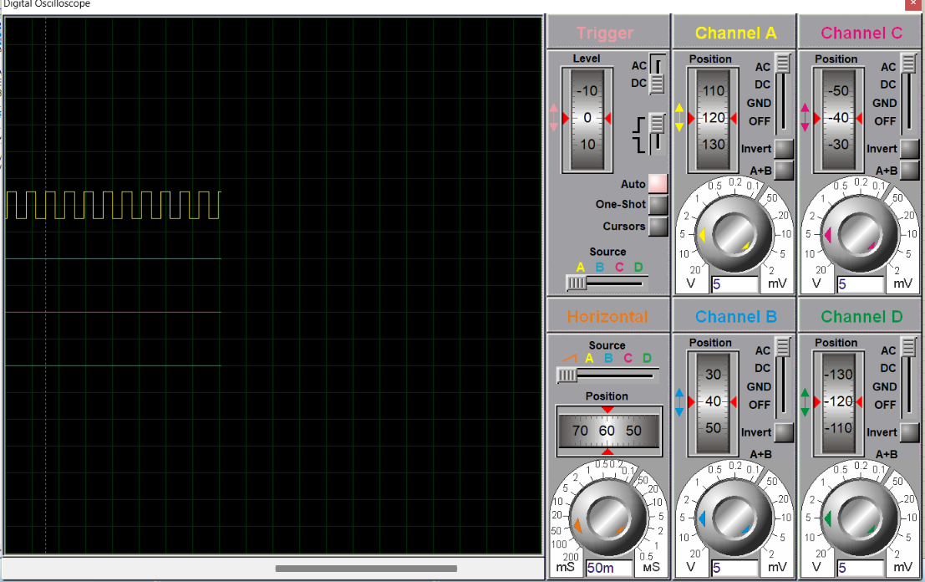

Exp No: 4

7 SEGMENT DISPLAY USING AT89C51 USING PROTEUS

Code:

ORG 0000H
UP:
MOV P2, #0C0H
ACALL DELAY
MOV P2, #0F9H
ACALL DELAY
MOV P2, #0A4H
ACALL DELAY
MOV P2, #0B0H
ACALL DELAY
MOV P2, #099H
ACALL DELAY
MOV P2, #092H
ACALL DELAY
MOV P2, #082H
ACALL DELAY
MOV P2, #0F8H
ACALL DELAY
MOV P2, #080H
ACALL DELAY
MOV P2, #090H
ACALL DELAY
SJMP UP
DELAY:
MOV R5, #10
H1:
MOV R4, #180
H2:
MOV R3, #255
H3:
DJNZ R3, H3
DJNZ R4, H2
DJNZ R5, H1
RET

END

Circuit:
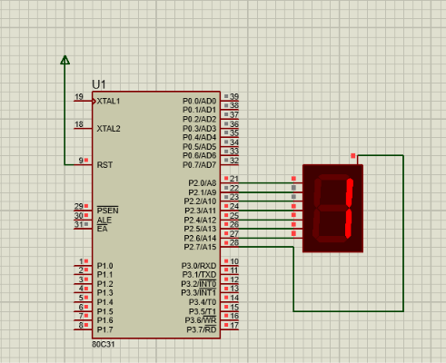

Exp No: 9
ARDUINO BASED MANUAL ELECTRONIC COUNTER USING PROTEUS
Code:
int x0, x1, x2, x3, x4, x5, x6, x7, x8, x9;

int delay_time = 200;

void setup()
{
// Configure pin 12 as input and enable internal pull-up resistor
pinMode(12, INPUT_PULLUP);

pinMode(1, OUTPUT);
pinMode(2, OUTPUT);
pinMode(3, OUTPUT);
pinMode(4, OUTPUT);
pinMode(5, OUTPUT);
pinMode(6, OUTPUT);
pinMode(7, OUTPUT);
}

void loop()
{
// Read the pushbutton value
int sensorVal = digitalRead(12);

if (sensorVal == LOW)
{
x0 = true;
}

while (x0)
{
zero();
sensorVal = digitalRead(12);

if (sensorVal == LOW)
{
x1 = true;
x0 = false;
}
}

while (x1)
{
one();
sensorVal = digitalRead(12);

if (sensorVal == LOW)
{
x2 = true;
x1 = false;
}
}

while (x2)
{
two();
sensorVal = digitalRead(12);

if (sensorVal == LOW)
{
x3 = true;
x2 = false;
}
}

while (x3)
{
three();
sensorVal = digitalRead(12);

if (sensorVal == LOW)
{
x4 = true;
x3 = false;
}
}

while (x4)
{
four();
sensorVal = digitalRead(12);

if (sensorVal == LOW)
{
x5 = true;
x4 = false;
}
}

while (x5)
{
five();
sensorVal = digitalRead(12);

if (sensorVal == LOW)
{
x6 = true;
x5 = false;
}
}

while (x6)
{
six();
sensorVal = digitalRead(12);

if (sensorVal == LOW)
{
x7 = true;
x6 = false;
}
}

while (x7)
{
seven();
sensorVal = digitalRead(12);

if (sensorVal == LOW)
{
x8 = true;
x7 = false;
}
}

while (x8)
{
eight();
sensorVal = digitalRead(12);

if (sensorVal == LOW)
{
x9 = true;
x8 = false;
}
}

while (x9)
{
nine();
sensorVal = digitalRead(12);

if (sensorVal == LOW)
{
x0 = true;
x9 = false;
}
}
}

void zero()
{
for (int i = 1; i < 7; i++)
{
digitalWrite(i, HIGH);
}
digitalWrite(7, LOW);
delay(delay_time);
}

void one()
{
digitalWrite(1, LOW);
digitalWrite(2, HIGH);
digitalWrite(3, HIGH);
digitalWrite(4, LOW);
digitalWrite(5, LOW);
digitalWrite(6, LOW);
digitalWrite(7, LOW);
delay(delay_time);
}

void two()
{
digitalWrite(1, HIGH);
digitalWrite(2, HIGH);
digitalWrite(3, LOW);
digitalWrite(4, HIGH);
digitalWrite(5, HIGH);
digitalWrite(6, LOW);
digitalWrite(7, HIGH);
delay(delay_time);
}

void three()
{
digitalWrite(1, HIGH);
digitalWrite(2, HIGH);
digitalWrite(3, HIGH);
digitalWrite(4, HIGH);
digitalWrite(5, LOW);
digitalWrite(6, LOW);
digitalWrite(7, HIGH);
delay(delay_time);
}

void four()
{
digitalWrite(1, LOW);
digitalWrite(2, HIGH);
digitalWrite(3, HIGH);
digitalWrite(4, LOW);
digitalWrite(5, LOW);
digitalWrite(6, HIGH);
digitalWrite(7, HIGH);
delay(delay_time);
}

void five()
{
digitalWrite(1, HIGH);
digitalWrite(2, LOW);
digitalWrite(3, HIGH);
digitalWrite(4, HIGH);
digitalWrite(5, LOW);
digitalWrite(6, HIGH);
digitalWrite(7, HIGH);
delay(delay_time);
}

void six()
{
digitalWrite(1, HIGH);
digitalWrite(2, LOW);
digitalWrite(3, HIGH);
digitalWrite(4, HIGH);
digitalWrite(5, HIGH);
digitalWrite(6, HIGH);
digitalWrite(7, HIGH);
delay(delay_time);
}

void seven()
{
digitalWrite(1, HIGH);
digitalWrite(2, HIGH);
digitalWrite(3, HIGH);
digitalWrite(4, LOW);
digitalWrite(5, LOW);
digitalWrite(6, LOW);
digitalWrite(7, LOW);
delay(delay_time);
}

void eight()
{
digitalWrite(1, HIGH);
digitalWrite(2, HIGH);
digitalWrite(3, HIGH);
digitalWrite(4, HIGH);
digitalWrite(5, HIGH);
digitalWrite(6, HIGH);
digitalWrite(7, HIGH);
delay(delay_time);
}

void nine()
{
digitalWrite(1, HIGH);
digitalWrite(2, HIGH);
digitalWrite(3, HIGH);
digitalWrite(4, HIGH);
digitalWrite(5, LOW);
digitalWrite(6, HIGH);
digitalWrite(7, HIGH);
delay(delay_time);
}

Components Required:
- Ardino
- Button
- 7 segment light
- ground

Circuit:
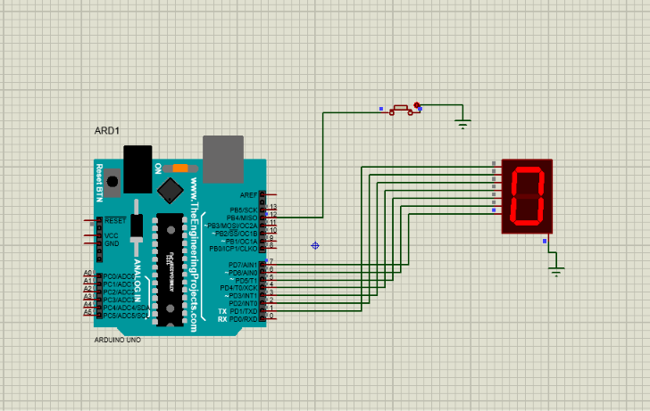

Exp No: 6
ARDUINO TO 16x2 LCD DISPLAY USING PROTEUS

Code:

#include <LiquidCrystal.h>

// LCD connections: RS, E, D4, D5, D6, D7
LiquidCrystal lcd(12, 11, 5, 4, 3, 2);

void setup()
{
lcd.begin(16, 2);
lcd.clear();

lcd.setCursor(0, 0);
lcd.print("HEY");

lcd.setCursor(0, 1);
lcd.print("ECE DEPARTMENT");
}

void loop()
{
// Keep the text stationary
}

Circuit:
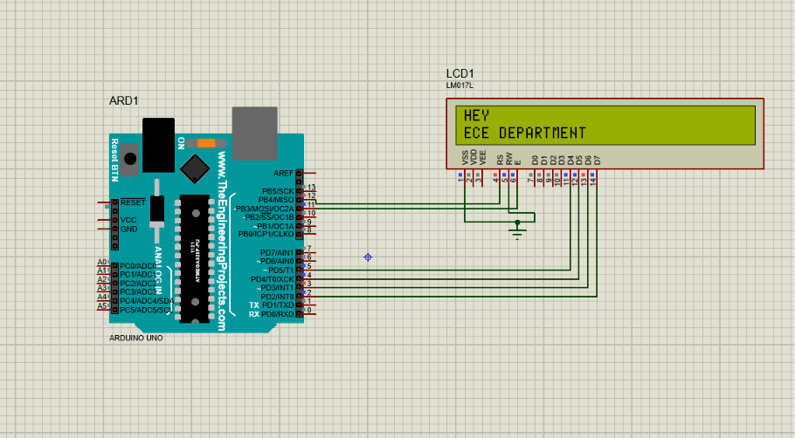
Components Reqiured:
1.ardino
2.lcd1
3.ground
4.ardino based

